CANNON AND NIKON’S MIRRORLESS CAMERA

This year is going to be exciting and fun for a photographer. Nikon and Canon are going to introduce their mirrorless cameras at the end of 2018.
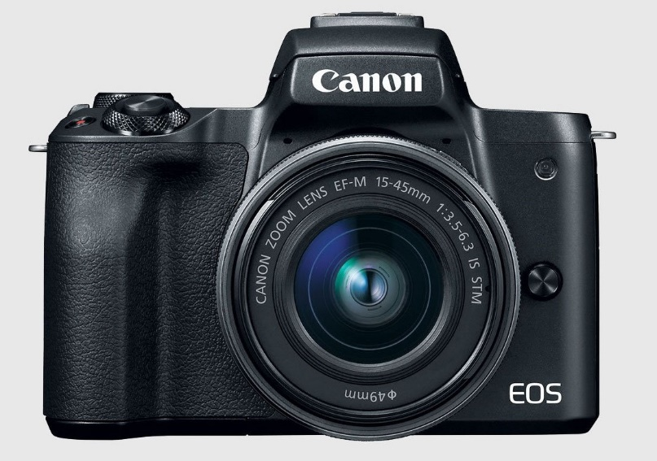
Photography has evolved over the past few years. It has become advanced with smartphones taking over. Thus, this is a time during, which DSLRs are now, considered to be used during a serious and much more mature shoot.
However, what are these new mirrorless cameras well let us break it down for you.
A mirrorless camera is a do away with the immense mechanical bits of a single-lens reflex camera. These cameras will have no virtual drawbacks because of the decrease in the mechanism. In fact, it will be a camera, which will outperform cell-phones. These mirrorless cameras can be used by professionals, and there are speculations that the camera will be used by professional photographers.
This is likely to become a huge part of photography. That is why every company is investing in it heavily.
For over a century these companies have been making the camera, it is the key to their identity in the camera market. Nikon is said to be releasing two versions of the mirrorless camera. One will have a high megapixel and the other will have a low megapixel.

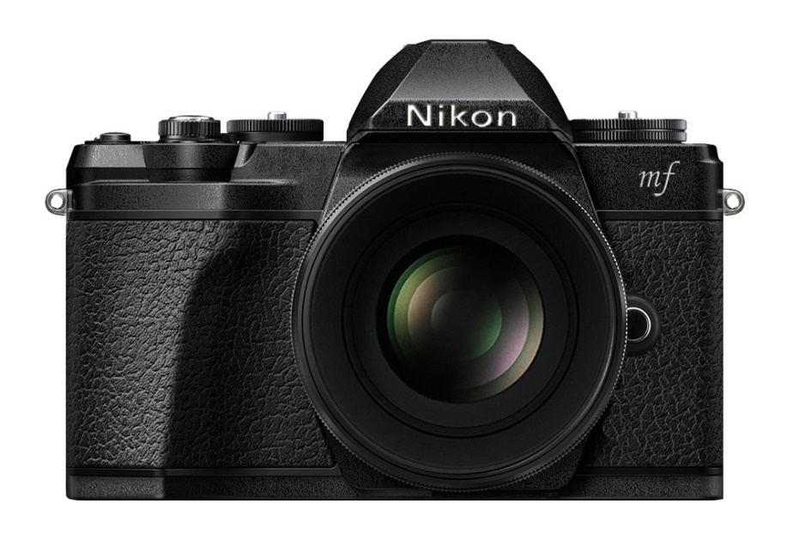
Nikon’s mirrorless models look promising. With the EOS R, Canon has made a strong full-frame mirrorless debut, but it lacks in the video department.

Canon's Dual Pixel system is rumored to be faster and better, especially for the video. It has an IOS range from 100 to 40,000, and it is expandable to 50-102,000. That is similar to Nikon's Z6 and Z7.
Apart from this, Canon is also offering a touch bar similar to the MacBook, which you will swipe with your finger to select focus when using the EVF. This is amazing news for all the vloggers, and selfie-takers out there. As the 2.1 million dots, touchpad also has a rotating, flappable display.
The Nikon Z –cameras, by contrast, have a tilting touch display.
However, photography lovers should not expect any lower cost to escort this change. These cameras are likely to cost around $2,500-$4,000 each.
This new technology will change the game for photographers, videographers. It is likely to bring a new perspective to the world of photography.
There reports that Cannon and Nikon plan to sell their full-frame mirrorless cameras by the end of the year.

