Highlights from Apple’s new Event.
Tim Cook kicked off the new event of Apple, for 2018. Technically this means, that we got all the insight about Apple's new and improved gadgets. The speculations for iPhone 2018 began at the end of 2017, just after the famous iPhone X was released. Thus, users knew that 2018 was going to be a big year for Apple, and considering the new event, Apple has made us all restless to get our hands on the new gadgets.
So, let’s have a look at the new devices that Apple has introduced.
- iPhone Xs and iPhone Xs Max
Apple introduced the new iPhone Xs and Xs Max. Looking at these two models, without any doubt they do look incredible, but let's have a look into what Apple is really offering us with the release of these two iPhones.
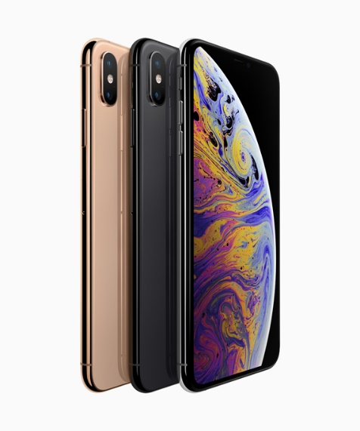
The iPhone Xs and Xs Max have the most advanced features ever. It has a 5.8-inch and 6.5-inch screen design. These two models feature striking Super Retina displays, with a faster and a much more improved dual camera system. Which offers a complete breakthrough photo and video features. With a beautiful gold finish and with the introduction of dual sim to iPhone.

- Apple Watch Series 4
Apple’s watch is the world’s #1 watch, in terms of sale. Thus Apple has to keep up its pace, with the new Apple Watch Series 4. It has been redesigned and re-engineered to help users stay connected, and manage their health in influential new ways. The new display seamlessly integrates into the thinner and smaller case. It has also introduced a new accelerometer and gyroscope. It can take an electrocardiogram (ECG) using the new ECG app.

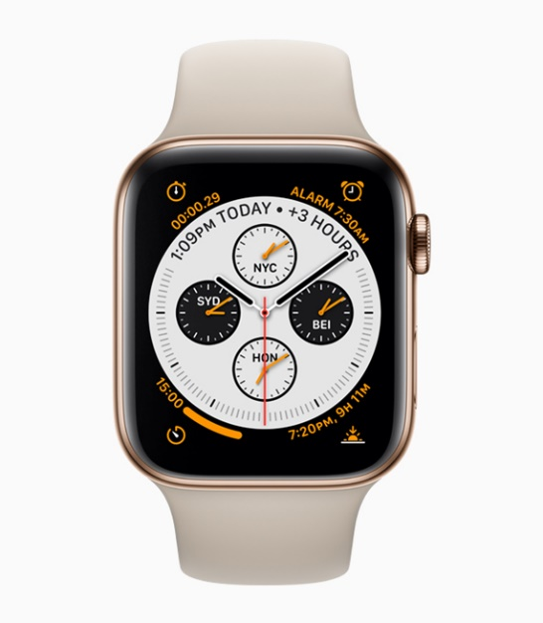

- iPhone Xr
Apple is also introducing, an iPhone, which is cheaper, but it has the same design and functions. It is made of aluminum like the older iPhones. It has a 6.1-inch LCD “Liquid Retina,” with a face ID.
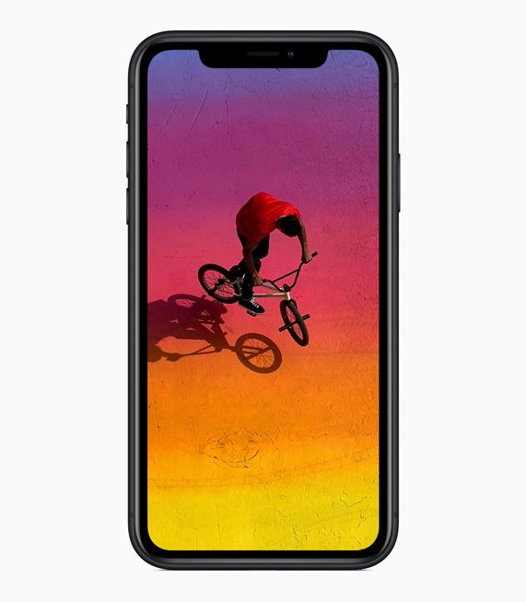

- HomePod
This is an interesting gadget by Apple for this year. The innovative wireless speaker has been added features that are more advanced. If you have any difficulty in searching for a song, well through HomePod you can now search by lyrics, even make phone calls, and set multiple timers.
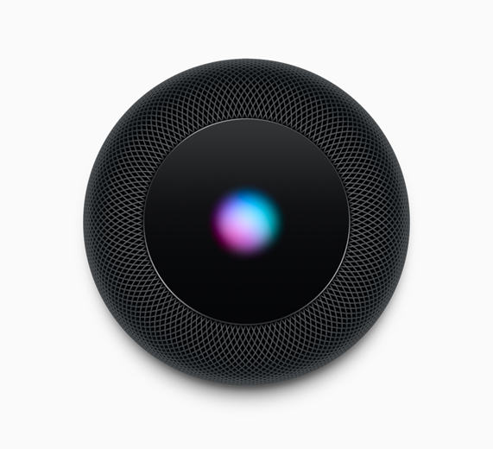

Apple has come up with the finest innovative gadgets, for this season. They have increased their target by catering to customers who want to join the Apple family. Without any delay, the iPhone Xs and Xs Max will be available for pre-order on Friday 14th September. While the iPhone Xr will be available for pre-order from Friday, 19th October, and in stores Friday, October 26th.

